**How to push new code to your repository (e.g. your exercises)**

**Anytime you make significant progress on your exercises, you should push the latest changes to GitLab.**

1. Navigate to your **individual student repository**   
     
   e.g. ***C:\Workspace\yourname-student-code***  
   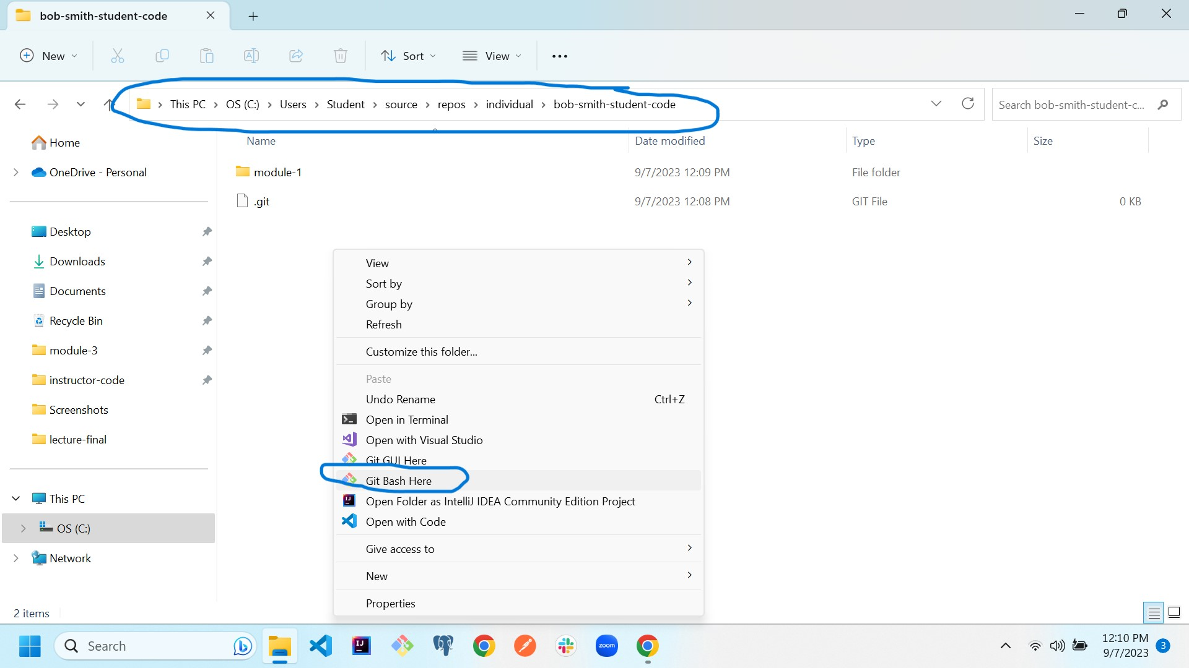
2. Right-Click in the open area and select: **Git Bash Here.** This will open git bash in the proper directory. **You must be inside your-name-student-code directory for git commands to work.**

**Run the following commands in order.**

1. $ git add -A
2. $ git commit -m “your comment”
3. $ git push **origin** main

***origin*** is the alias for your remote repo. Never check in code that does not compile. Get it to a state that at least compiles (even if your code does not run) then push your code.  
  
**If the code is not pushed to your remote repository, we (Bootcamp OS) can’t see it to grade it. If code is not in your remote repository then it can’t be recovered if your laptop crashes.**

Watch the output for failures! If you see a failure, reach out to an instructor ASAP.

You can verify what has been submitted by looking at the file in GitLab via your browser

You can push as often as you like. Only the last changes made will be reviewed.  
  
**When ready for scoring, don’t forget to submit to BootcampOS!**